String Handling
____________________________________________________________________________
Q. what is string?
___________________________________________________________________
String is a collection of characters or it is character array.

Syntax: char variablename[size];
Example: char name[90];

Q. what is diff between character array and other type of array?
___________________________________________________________________
Character array ends with \0 but integer array or other type of array not ends with \0
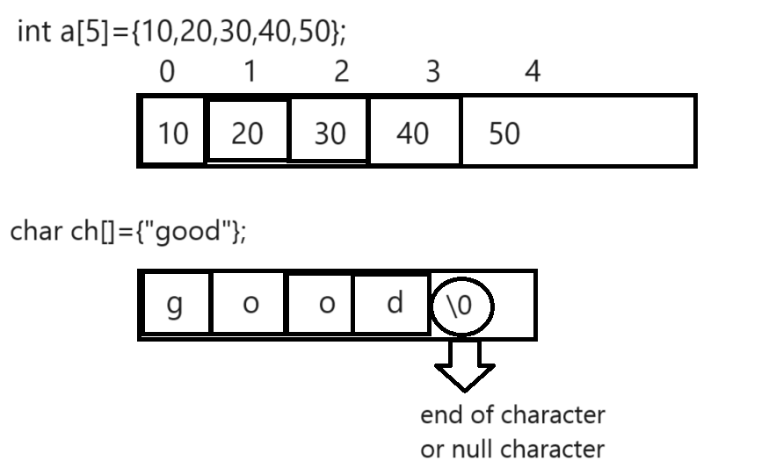
if we want to accept input of character array we have %s modifier
Example: WAP to accept input as string and display it.
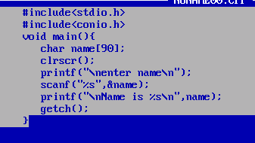
Output:
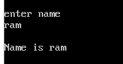
Second output
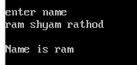
If we think about above output we provide input with space but scanf() cannot read input after space.
if we want to accept string input with space we have one function name as gets()
gets() function specially design for accept string input
Syntax: gets (char[]): accept string type of input with space.
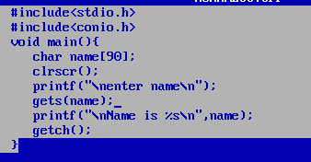
Output:
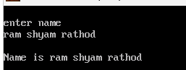

If we want to work with String we have some inbuilt function provided by string to us

int strlen(char[]): this function can calculate length of string.
Example:
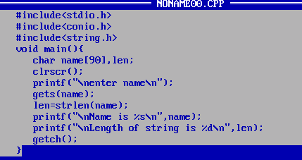
Output:
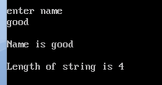

Example: WAP to input string and calculate its length without using strlen() function?
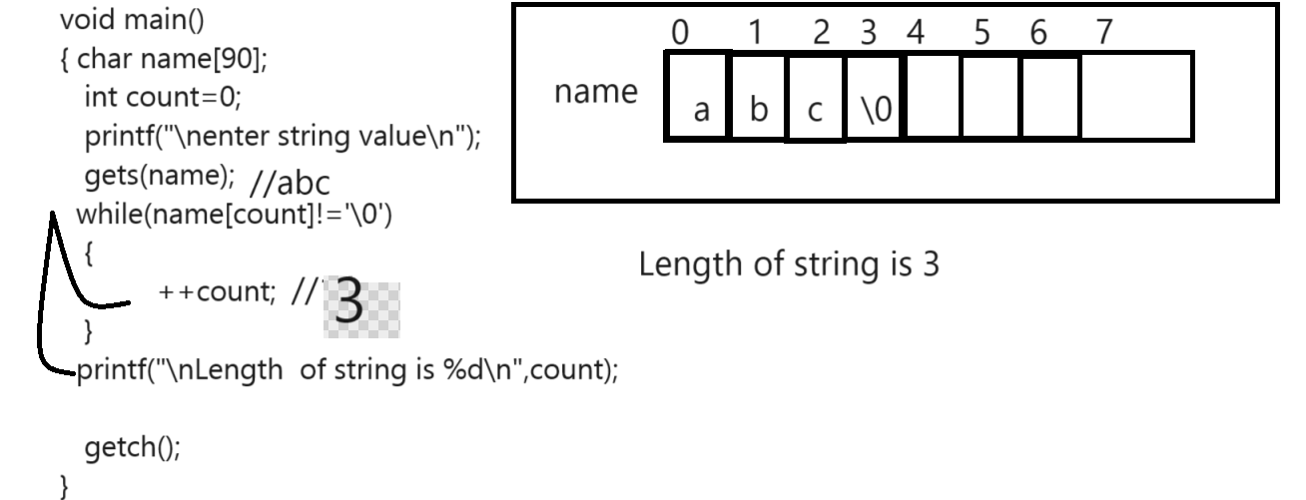

Example:
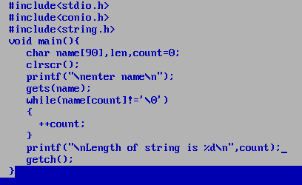

strupr(char[]): this function is used for convert your lower case string to upper case string.
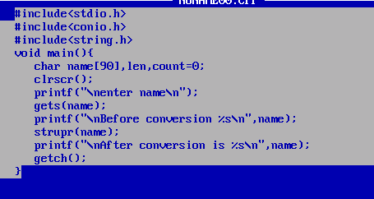
Output:
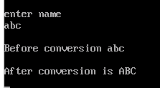
Example: WAP to accept string input from keyboard and convert lower case string to upper case.
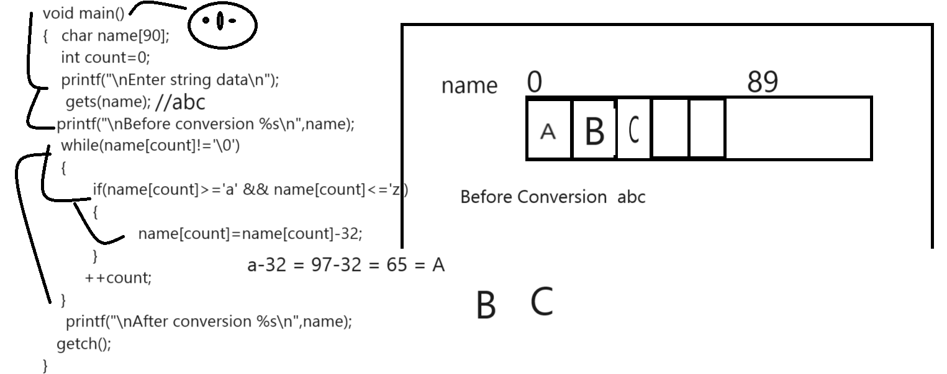

Example:
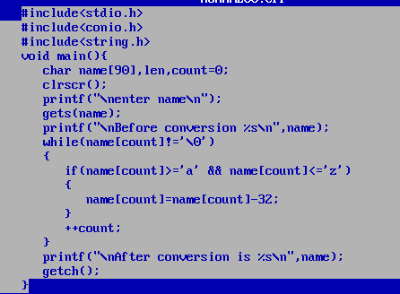

strlwr(char[]): this function can convert your upper case string to lower case.

int strcmp(char[],char[]): this function can compare the two strings with each other and if strings are
equal return 0 otherwise return first mismatch ascii code difference
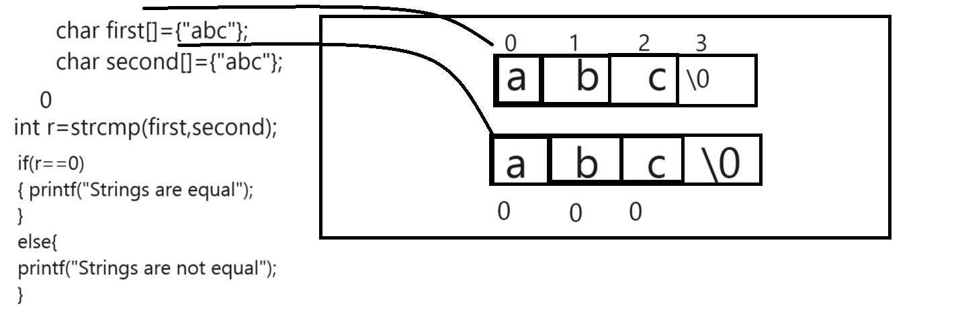

Example:
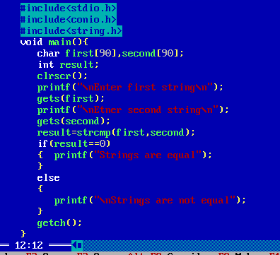
Example: WAP to input two strings and compare them without using strcmp() function
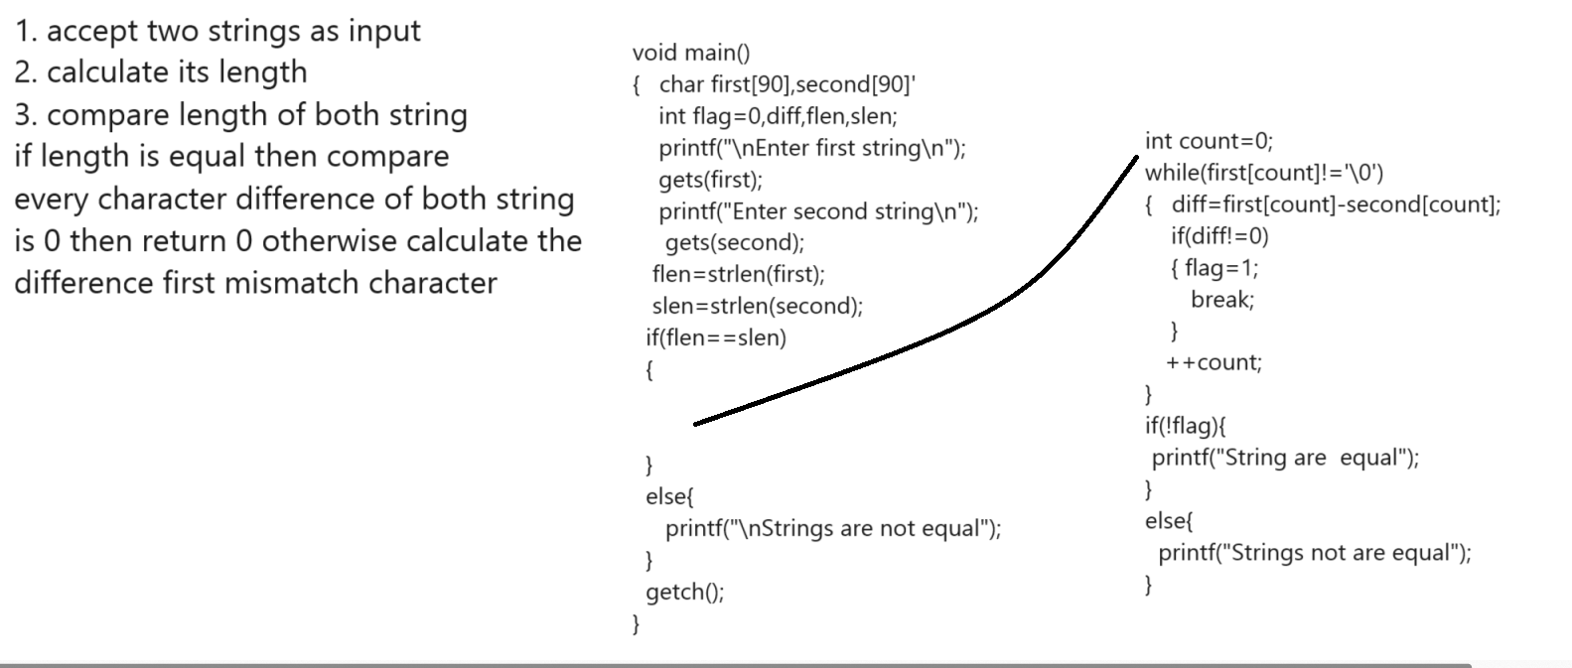

Example:

Q1. WAP to input string and reverse it without using inbuilt function?
Q2. WAP to input string and extra digit from it and calculate its sum?
Example:
abc124mno35
Output: 1+2+4+3+5 = 15
Q3. WAP to input string and reverse the words of string ?
Example: abc mno pqr
Output: cba onm rpq
Q4. WAP to input string and convert first letter of every word as capital?
Example: input : abc mno pqr
Output: Abc Mno Pqr

Q5. WAP input string and Calculate the vowel,consonant in string

strcat(char [],char[]): this function can concat two strings with each other means combine
right hand string to the left hand string.
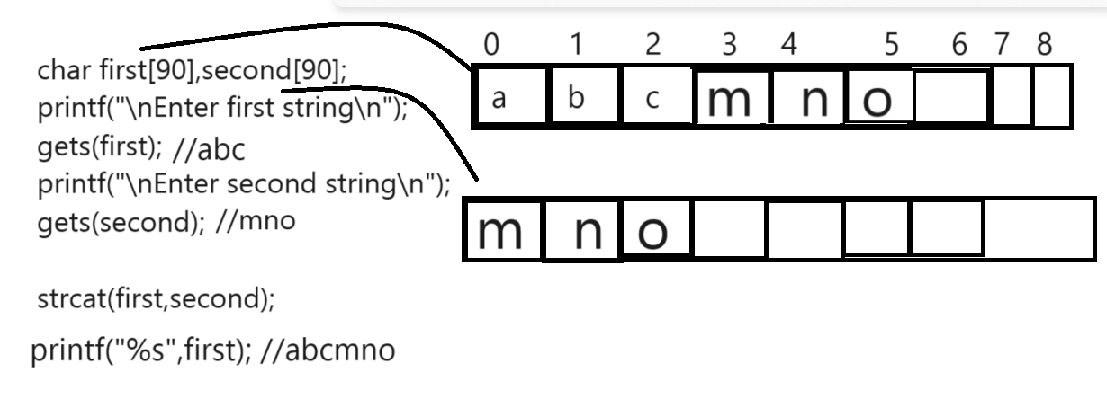
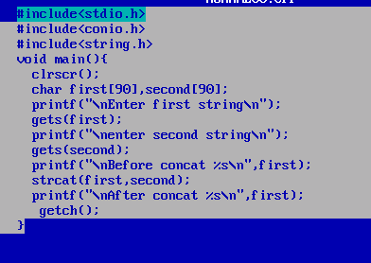
Example: WAP to input two strings and concat them without using strcat() function?

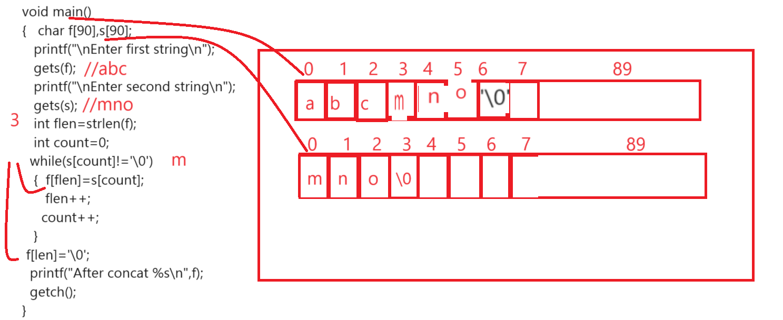4
strcpy(char[],first[]): this function is used for copy the right string data in to left hand side string.
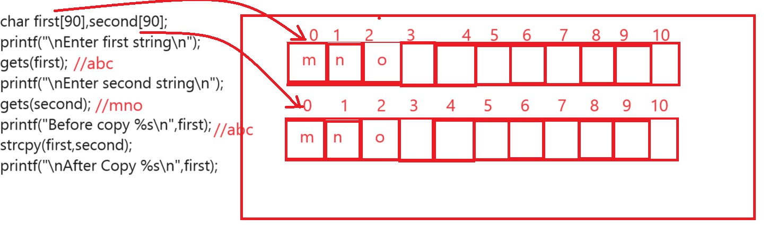
Example: WAP to copy the one string to another string without using strcpy?
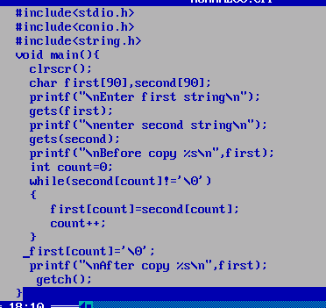
How to access string by using pointer?
________________________________________________________________________
If we want to access string by using pointer we have store the base address of string in pointer variable.
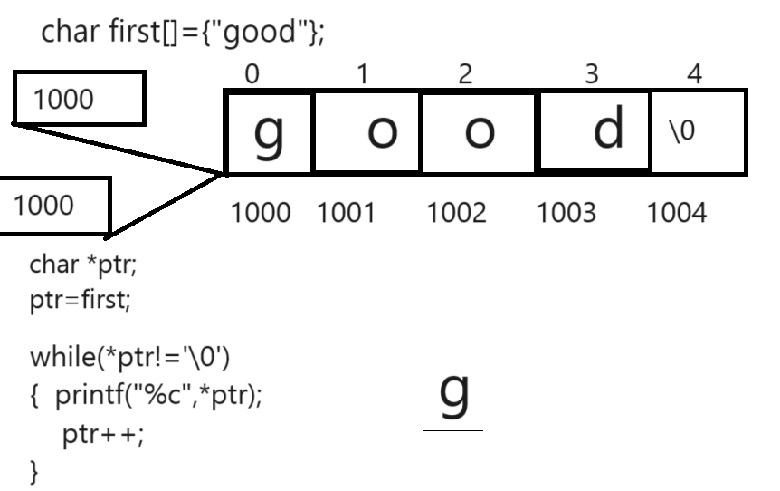
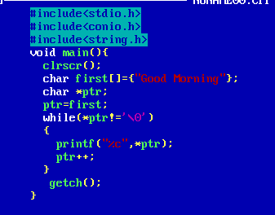
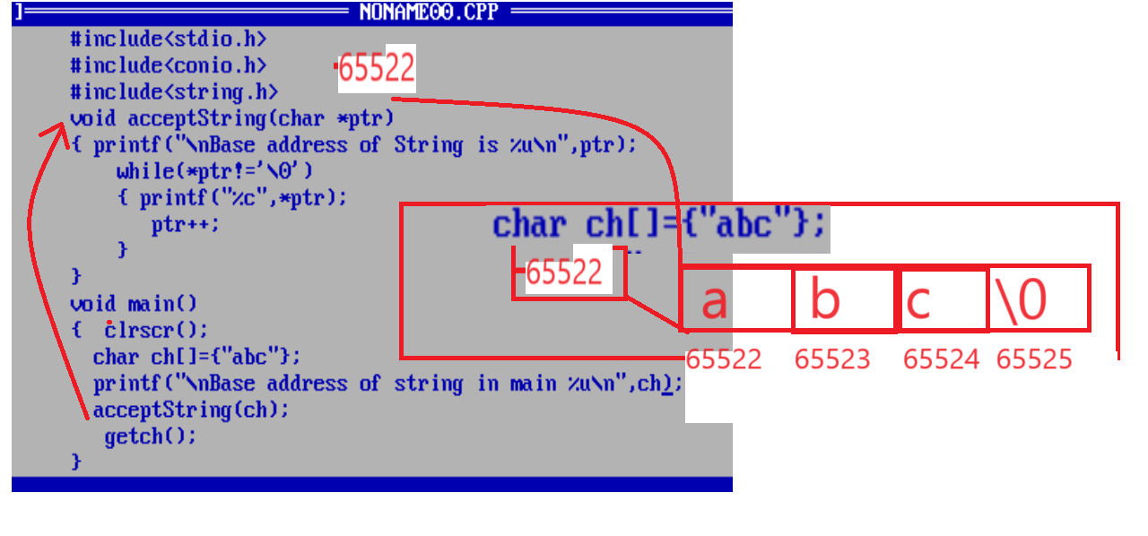
Example: what will be output of given code?
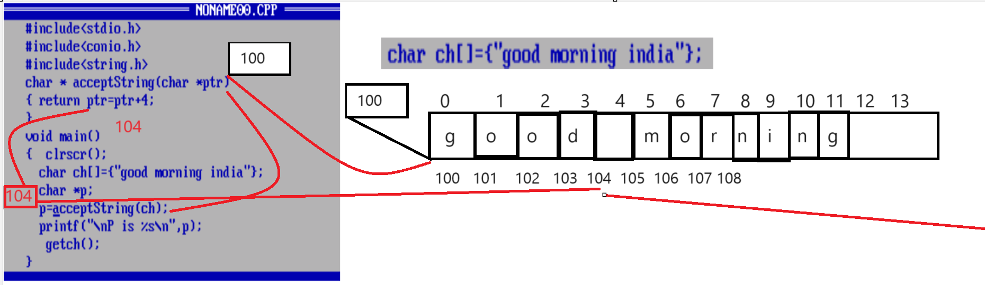
Output: morning india.
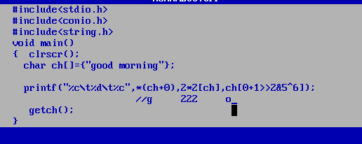
Two Dimensional Strings
__________________________________________________________________
Two dimensional strings is used for work with multiline text or paragraph
Example: char name[5][90];
We have five lines of text and every line contain 90 characters.
